ZIRAAT LODGES   
AND   
TEACHINGS



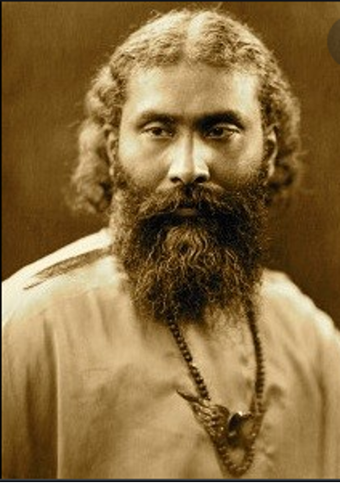

Pir-o-Murshid Hazrat Inayat Khan

### Contact

**Email:** ziraat@inayatiyya.org

**Ziraat website:** [inayatiyyaziraat.org](http://inayatiyyaziraat.org/)

**Inayatiyya website:** <https://inayatiyya.org>

**Copyright**

*© Inayatiyya Ziraat 2022 Revision*

*This printing does not constitute publication.*

## The Symbology of the Harrow

The Harrow is the thought held in the hands of the Will to make the earth finer, softer, and to take away all the objects, pebbles and small roots still left in the ground.

These pebbles are the hardened feelings, feelings of prejudice, of malice, revenge, antagonism, and they must be taken away from the ground in order to make it ready for sowing. And there are little roots to be found there that signify undesirable thoughts which still remain in the ground after it is ploughed. They must be taken out that they not remain as obstacles to sowing.

The prongs of the harrow are the currents of thought, and the shaft of the harrow is symbolical of intelligence which is held by the will. The horse which is yoked to the harrow is energy which is the driving force of the Harrower and is the ever-growing enthusiasm.

The Harrower must take to heart the responsibility of his work. Unless the sense of responsibility is awakened in the soul, the spirit of the workman is not born. It is in making the duty a pleasure that the work will be lightened for the workman. Center your mind in the work so that a stream of inspiration may rise out of it.

*Teachings of the Great Farmer – Hazrat Inayat Khan*

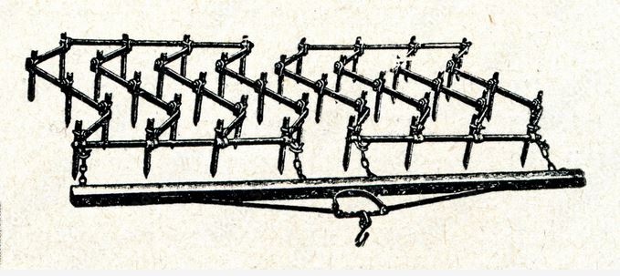

*27*

## Table of Contents

**Ziraat Stations** 1

**Ziraat Ceremonial Altar** 2

**The Formal Ziraat Lodge** 3

Salutations to the Elements 4

Ziraat Dialogue 5

Address of the Great Farmer 7

**The Informal Ziraat Lodge** 9

**Initiation Ceremonies**

Traditional Reception of Laborers 12

Non-Traditional Reception of Laborers 15

Additional Vows 17

**Ziraat Teachings**

Symbolic Work on the Farm 19

Symbology of the Plough 20

Cultivating the Mind 21

Self-Analysis 22

Purification of the Mind 23

Doing Our Own Work 24

The Method of Ploughing 25

The Method of Harrowing 26

The Symbology of the Harrow 27

**ZIRAAT STATIONS**

**The Sovereign of the Farm** (The One and Only Being)

**The Great Farmer** (Hazrat Inayat Khan)

**The Most Experienced Farmer**

(Pir Zia Inayat Khan - Head of the Inayatiyya)

**Experienced Farmer**

**Farmer**

**Worker**

**Laborer**

In 2022, the Inayatiyya altered the traditional initiation levels to reflect a less hierarchical structure and to modify language that may be offensive for cultural or other reasons. Those who have received an initiation of Plougher, Harrower, Sower, Reaper, Thresher, or Garnerer will now be known as Workers. Laborers are those who are interested in Ziraat but are not formal members.

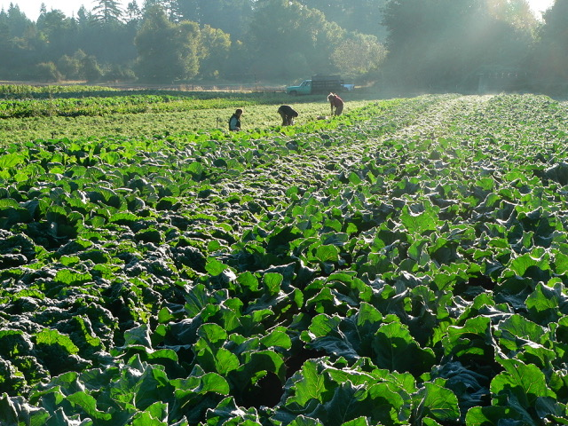

*1*

## The Method of Harrowing

In the ground, there are to be found deep roots and roots that are still lying on the surface. There are also pebbles which are sticking in the ground and others lying on the surface. In ploughing, much of the undesirable element is taken away from the ground and yet much is still to be found. It is in harrowing that we must clear away what is remaining.

Deep roots are feelings that have taken a root in the subconscious mind. They are feelings of malice, of prejudice, of jealousy, of deceit; the feelings of conceit, of contempt, of revenge, and of spite. The roots which are lying on the surface are the ill-manners; such as the cutting word, the rude movement, the insolent form, the harsh voice and crude gestures. By deeply rooted pebbles is meant beliefs, superstitions, habits, weaknesses which still exist in the mind. The pebbles on the surface are tendencies, inclinations, thoughts and imaginations that lead to wrongdoing.

The human mind is likened to the treasure buried in the ground; it needs digging. And when the earth and stones that cover the treasure are removed, then the treasure manifests to view.

The Harrowing, therefore, is the finishing of that clearing process which began in the form of Ploughing.

*Teachings of the Great Farmer - Hazrat Inayat Khan*

*26*

## The Method of Ploughing

Before a field can be sown with fresh seed, everything previously sown there must be cleared away, the field left empty and bare to the purifying rains and winds of God. But even that is not enough, for underneath the brown earth, deep down and hidden from sight, there may be many old roots and stems of a past Harvest.

All these must be uprooted before the sowing can begin. This is the work of the Plougher who, once having begun work, must continue to the end, for “no one having put their hand to the plough and looking back, is fit for the Kingdom of God.”

Every part of the field must be ploughed up and the furrows made straight and deep. From Sunrise to Sunset must one labor until the field is ready for sowing. Nevertheless, of this task one must not weary, for in the heart of the Plougher is the joy of a fresh beginning and the labor of one’s hands shall be blessed. In the solitude of one’s toil, one shall not feel alone for, in one’s Soul one heareth the “Song of Return”.

Blessed is the one who thus prepareth the field.  
Verily, one’s feet shall tread on the Path of Wisdom.

*Teachings of the Great Farmer – Hazrat Inayat Khan*

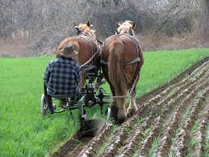

*25*

# ZIRAAT CEREMONIAL ALTAR

Traditionally, the base of the Ziraat altar was covered with a gold cloth and the following placed upon it:

**Earth** a small bowl of soil or flowers

**Water**  a container of water

**Fire**  a lit candle

**Air** a feather or fan

**Ether** lit incense

*The incense can remain unlit if lit incense is problematic for those present.*

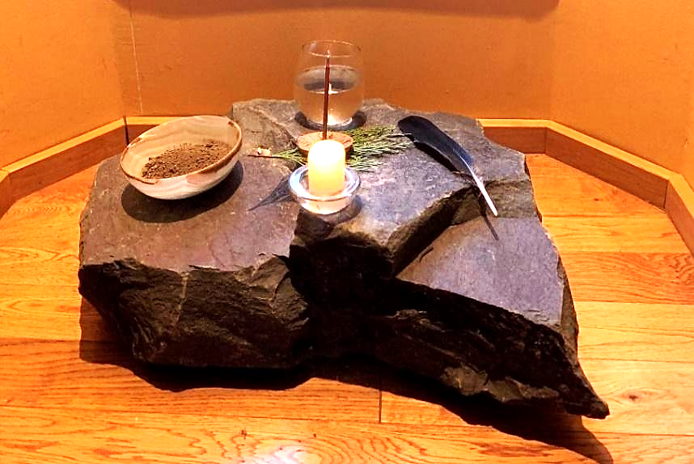

You are free to be creative when making a Ziraat altar, while still embodying the symbols that Hazrat Inayat Khan gave us. Personal creativity can deepen the meaning expressed in the altar. Altars can be outdoors or indoors. Creating an altar is also a wonderful group activity. The photo is one example of a Ziraat altar.

*2*

# THE FORMAL ZIRAAT LODGE

This 2022 revision includes gender neutral pronouns and less archaic language. It updates some Ziraat terminology, alters the initiation levels, eliminates the use of ceremonial cords and provides options for the Reception of Laborers. Additionally, several options are presented as to how the Ziraat Lodge and Initiations may be conducted.

Lodges may be led by The Most Experienced Farmer, Experienced Farmers and Farmers. Workers with significant Ziraat experience may also lead lodges with permission.

## The Formal Ziraat Lodge

### Sufi Invocation

*All together, preferably standing*

Toward the One, the Perfection of Love, Harmony and Beauty, the Only Being, united with all the Illuminated Souls, who form the embodiment of the Messenger, the Spirit of Guidance.

### Ziraat Invocation

*Lodge leader standing, hands raised, palms upward*

We invoke the Presence of the Sovereign of the Farm.

We offer our wholehearted devotion to the Great Farmer.

### Greetings

*Lodge leader standing*

**Leader:** Our faithful greetings to you, our Ziraat Family.

**Members:** Our respectful greetings to you, our Experienced Farmer /Farmer /Lodge Leader.

*3*

## Doing Our Own Work

The spiritual force that is pouring out on the world today is quickening every kind of seed in the human heart.

If the seeds are quickened, the harvest must be reaped. That is the law.

We cannot help until the field is again clear. What we can do is to sow fresh seeds and nourish them until they are quickened. But the reaping thereof will be for other hands.

There are Ploughers in the field and there are Reapers of the harvest. All are different, and one cannot do the work of the other. But all are working out the divine plan and all are necessary to the others.

To a little band of Sowers has been given a handful of living grain.

Faithfully, it must be sown, surely, it will be reaped; and the harvest shall be for the sustenance of all who are hungering for the “Bread of Life”.

*Words of the Great Farmer - Ziraat Lesson Five*

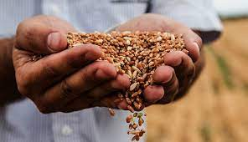

*24*

## Purification of the Mind

Roots which become settled in the uncultivated ground of mind are of different tendencies: the tendency to like or dislike, to love or hate, the tendency to yield or dominate. Desirable tendencies, if left in an uncultivated soil to grow by themselves prove in the end profitless, for they have not sufficient scope to grow together with the undesirable ones, and these cannot be rooted out without taking with them some of the desirable ones.

It is the clearing away of the whole foreign element from the soil that is necessary in order to fully cultivate the ground. Ploughing, therefore, is not purposed to remove only the roots that are not needed there but also those which are needed.

The process of purification does not mean that all which is desirable should remain and the undesirable be thrown out. It means that every substance that is to be purified must be purified of all that is foreign to it, in other words, of that which does not belong to it.

Many good tendencies, when growing with a bad one, lose their value, for the good tendency has no scope to grow together with the bad. Therefore, in order to cultivate the mind, good and bad tendencies both should be rooted out.

It must be remembered that there is no loss if the good ones are rooted out with the bad, for mind in its essence is incomparably superior to all good tendencies.

By cultivation of the mind, when the foreign element is rooted out, the mind becomes pure, and the person becomes one’s own self.

*Words of the Great Farmer - Ziraat Lesson Four*

### *23*

### Salutations to the Elements

*All together, preferably standing*

**O, all-productive Earth,**

**we humbly offer our homage to Thee.**

*Standing straight, arms down slightly out from sides, palms parallel to the earth*

**O, all-purifying Water,**

**we willingly offer our homage to Thee.**

*Hands at forehead, fingers pointing downwards almost touching, imitating water dripping*

**O, all-consuming Fire,**

**we wholeheartedly offer our homage to Thee.**

*Hands crossed over head, right in front of left, fingers upward, imitating a flame*

**O, all-pervading Air,**

**we gladly offer our homage to Thee.**

*Arms in the same position as above wrists crossed waving slightly front-to-back*

**O, Ether, essence of all,**

**we passively offer our homage to Thee.**

*Arms crossed over chest, right over left, with hands on shoulders*

*4*

### The Ziraat Dialogue

*Between two designated attendees*

For what purpose have we assembled here?

*For Farming*

What is the length of the Farm?

*As long as time*

What is the breadth of the Farm?

*As broad as space*

To whom does the Farm belong?

*It is our parents’ heritage*

What is the Farmer’s religion?

*The Farmer’s work*

With what attitude does the Farmer work?

*The Farmer ploughs with toil, sows with hope and reaps with joy.*

What is the achievement of the Farmer?

*A successful harvest*

What are the principles of the Farmer?

*Good seed is more precious than pearls; Fertile soil is more valuable than gold; That an experienced Farmer can make greater riches by sowing, than a moneylender by the interest earned on money.*

Of what does Farming consist?

*Mainly of three kinds of work:   
ploughing, sowing and reaping*

*5*

## Self-Analysis

The birth of every purpose is when the purpose has become known. The moment one knows, “I am my mind”, one begins to analyze what one’s mind contains. If it contains error, one finds oneself in error; if it contains pain, one finds oneself sad; if it contains fear, one feels discomfort. If one finds an accumulation of desirable and undesirable impressions, thoughts that one likes and dislikes, one feels confused. To feel in one’s mind thoughts that one cannot bear to think is like standing in the mud.

Finding one’s imaginations undesirable and uncontrollable is like being in a forest among wild beasts who are not under one’s control. To feel one’s weaknesses and defects is like being in the wilderness where life is every moment in danger. All these are different roots that are to be found in the soil of the mind, and it needs “willpower” to uproot and cast them out.

The first work of the Plougher (or Adept) or seeker on the path is self-analysis. Once self-analysis is made, the human being has brought out from the soil of the mind all that was there onto the surface so that nothing either good or bad remains buried there.

Self-analysis is the first necessary process in cultivating the mind. It brings out all that was within onto the surface, open for inspection. In this manner, a person can judge oneself fully like Plougher who sees all that was buried under the ground when it is turned up in the furrow.

Nothing can give the Plougher greater pleasure than to see the results of one’s efforts in bringing to the surface all that was buried and in feeling that one has thoroughly penetrated the ground and brought to the surface all that was hidden there.

*Words of the Great Farmer - Ziraat Lesson Three*

*22*

## Cultivating the Mind

The human mind contains various possessions collected and accumulated throughout life, some lying on the surface of the mind and others buried in it, desirable and undesirable; all sorts of impressions, right and wrong thoughts, conceptions of good and bad, memories of sins and virtues, merits and defects. All lie there buried.

Some take root in the soil of the human heart; others are hindered by not having scope for seeding. In this way, the human mind becomes a wild forest where flowers and weeds both grow, a soil whose purpose is to become fertile wherein the substance for life may be produced.

The uncultivated mind is a barren desert where the soul is starved for the food it hungers after. Every effort that one makes to turn this desert into fertile soil is action done in the right direction.

On one side, by the Jemal attitude, that is by thinking and reading about the value and purpose of one’s mind, one cultivates the ground within oneself.

By the Jelal attitude, that is by the power of the mind, one is able to accomplish one’s work.

One’s own self is the plough; understanding and power are the two wheels of the plough. With this plough, one works on the soil of the mind and takes away frost, all roots of flowers and thistles both, thus making the ground free from every kind of root and stone, making it softer and smoother, almost ready to sow the seed.

*Words of the Great Farmer - Ziraat Lesson Two*

### *21*

What fertilizes the soil?

*Cultivation*

What nourishes the land?

*Water*

What raises the crops?

*The Sun*

At what time of day is ploughing done?

*At dawn*

At what time of day is sowing done?

*At sunrise*

When does the Farmer take the midday rest?

*When the sun reaches its zenith*

At what time of day is reaping done?

*Towards sunset*

What does a Farmer do at night?

*The Farmer keeps watch*

What does a Farmer do during the day?

*The Farmer works*

When does a Farmer begin work?

*When the moon is waxing*

When does a Farmer rest from work?

*When the moon is waning*

### *6*

### The Address of the Great Farmer

I should like to speak a few words upon the need of cultivation of our souls, our hearts and of our minds. The human in essence of being is divine. The source from which the human soul has come is the Eternal One. But in order to manifest in human form, the soul has to pass through different phases, and the process through which the human soul manifests, being conscious and afterwards unconscious is when the soul realizes, “I am a human being”.

In the journey, the soul has passed not only through the angelic and djinn spheres, but through rocks and plants and through lower creation it has risen to become human.

Therefore, through all the names and forms we see in this world, even of the smallest germs and insects, the soul is working out its perfection to express itself in humanity.

A picture of the journey may be made as if an angel from the highest Heaven came down and descended to the lowest depths of the earth and from there, feeling after and longing for the Paradise it has left, has worked its way through the lower creation and arrived at the form of the human being.

Although in essence, even after touching the deepest depths of the earth, the soul is divine. In order to realize for itself that Divine Element, it has a task waiting even after being [becoming] human, and it is the manner in which that task is accomplished and the object gained which is called Ziraat, in which we all unite to offer our homage to the Sovereign of the Farm.

*7*

## Symbology of the Plough

**Jelal:** *Intensity, strong vibrations, straight, masculine*

**Jemal:**  *Gentleness, mild vibrations beauty, grace, feminine*

**Kemal:** *Conflict of both forces, also perfection, the blending of Jelal and Jemal*

The plough is symbolic of Prana, the breath. The large wheel represents the Jelal power of the breath, and the small wheel represents the Jemal power of the breath – both attached to one axle, meaning that both work in one body.

But the smaller wheel follows and rotates at a different angle to the other, showing that Jemal is a complement to Jelal, also signifying that Jemal is the response to Jelal; or it is the two forms of Jelal and Jemal that form the rhythm, which is the Cause behind every action. Without action, there is no life, and action must manifest in rhythm.

The blade attached to the plough and which cuts the stems and roots is Willpower. Its every action may cut the stems and roots of thought and imaginations which stand in the ground undesirably.

The plough itself represents the human being who possesses all these qualities. The absence of Jelal or Jemal would paralyze the actions of life. If willpower were absent, one’s life would be like a plough without a blade. If the Jelal wheel were too small or the Jemal wheel too large, they could not go together; the plough would not be balanced. And so, in the life of human beings, it is harmony and the evenness of Jelal and Jemal forces which help the continuity of harmony and balance of life.

*Words of the Great Farmer - Ziraat Lesson One*

*20*

# ZIRAAT TEACHINGS

## Symbolic Cycle of Work on the Farm

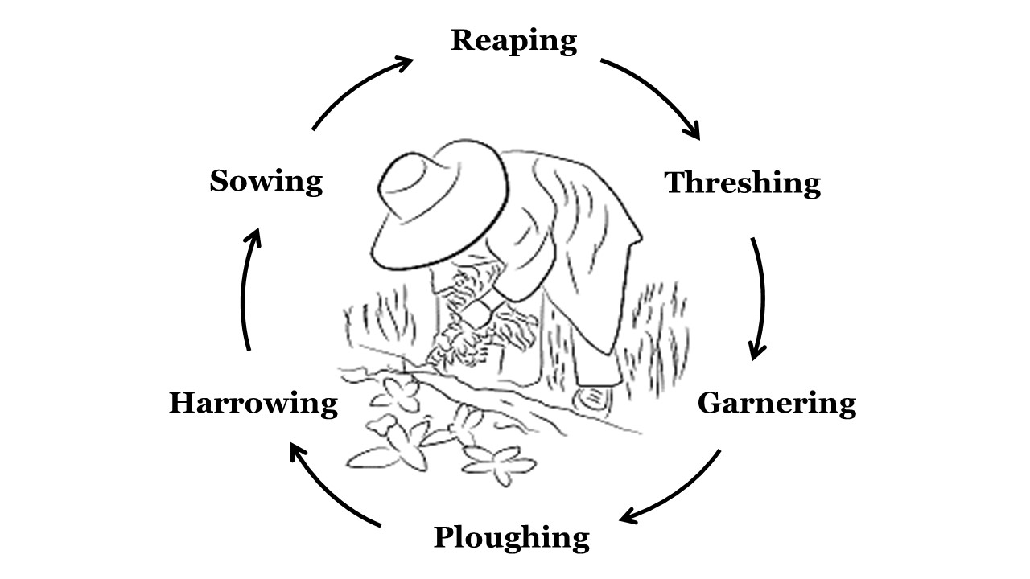

|  |  |  |
| --- | --- | --- |
| Work | Watchword | Symbol |
| Ploughing | Toil | Plough |
| Harrowing | Courage | Harrow |
| Sowing | Hope | Grain |
| Reaping | Joy | Sickle |
| Threshing | Strength | Flail |
| Garnering | Thanksgiving | Barn |

### *19*

### Initiations

*Refer to page 12 for initiation ceremony options*

### Reading from Ziraat Teachings (Optional)

### Meditation on Ziraat Teachings (Optional)

### Salutations to the Elements

*Preferably standing, all together, performed silently, with hand positions*

### Closing

*Traditionally done by the Leader, but others may join*

Let us depart, knowing ourselves the willing workers of the Sovereign of the Farm, in whose service is Perfect Freedom.

### Prayer Khatum (Optional)

O Thou, who art the Perfection of Love, Harmony and Beauty, The Sovereign of heaven and earth, open our hearts, that we may hear Thy Voice, which constantly comes from within.

Disclose to us Thy Divine Light, which is hidden in our souls, that we may know and understand life better.

Most Merciful and Compassionate God,   
Give us Thy great Goodness,  
Teach us Thy loving Forgiveness,   
Raise us above the distinctions and differences   
which divide us.

Send us the Peace of Thy Divine Spirit,  
And unite us all in Thy Perfect Being. Amen

# *8*

# THE INFORMAL ZIRAAT LODGE

The Informal Ziraat Lodge offers great flexibility. The Lodge opens with the Ziraat Invocation, Greetings, and Salutations to the Elements, but then may include Ziraat related teachings, topics, practices, discussions, songs, readings, etc. The Lodge closes with the Salutations to the Elements done silently, and the closing phrase.

The Informal Ziraat Lodge includes a number of structural and terminology modifications that reflect the changing times.

Lodges may be led by the Most Experienced Farmer, Experienced Farmers, and Farmers. Workers with significant Ziraat experience may also lead lodges with permission.

## The Informal Ziraat Lodge

### Sufi Invocation

### *All together, preferably standing*

Toward the One, the Perfection of Love, Harmony and Beauty, the Only Being, United with all the Illuminated Souls, who form the embodiment of the Messenger, the Spirit of Guidance.

### Ziraat Invocation

*Lodge leader standing hands raised, palms upward*

We invoke the Presence of the Sovereign of the Farm.

We offer our wholehearted devotion to the Great Farmer.

### Greetings

*Lodge leader standing*

**Leader:** Our faithful greetings to you, our Ziraat Family.

**Members:** Our respectful greetings to you, our Experienced Farmer /Farmer /Lodge Leader.

*9*

**Initiator:** I recognize and accept this Worker as a companion on the Ziraat path.

**Initiator:** *With palms forward toward the Worker*

May your labor be approved by the Sovereign of the Farm.

In the Name of God, the Sovereign of the Farm, I bless you.

*Lightly touch the top of the head of the Worker and, without touching the Worker, move hands downward on either side of the Worker.*



*18*

## Additional Vows (Optional)

**Initiator:**   
Will you honor and protect the Earth with gratitude, allowing Earth’s generosity to transform that which you no longer need, and allowing Earth’s fertile seedbed to nurture your service in the world?

**Laborer:** *I will.*

**Initiator:**   
Will you honor and protect the Water with gratitude, allowing Water to wash away that which you no longer need, and allowing the flow of life-giving Water to give growth to your initiatives of service in the world?

**Laborer:** *I will.*

**Initiator:**   
Will you honor and protect the Fire with gratitude, allowing Fire to burn away that which you no longer need, and allowing Fire to fill you with light and warmth, and motivate your endeavors in the world?

**Laborer:** *I will.*

**Initiator:**   
Will you honor and protect the Air with gratitude, allowing Air to blow away that which you no longer need, and allowing Air to creatively inspire you in your service to the world?

**Laborer:** *I will.*

**Initiator:**   
Will you honor the Ether with gratitude, allowing Ether to disclose to you the essence of Life, your interconnectedness with all beings, in the unity of the One?

**Laborer:** *I will.*

*17*

### Salutations to the Elements

*All together, preferably standing*

**O, all-productive Earth,**

**we humbly offer our homage to Thee.**

*Standing straight, arms down slightly out from sides, palms parallel to the earth*

**O, all-purifying Water,**

**we willingly offer our homage to Thee.**

*Hands at forehead, fingers pointing downwards almost touching, imitating water dripping*

**O, all-consuming Fire,**

**we wholeheartedly offer our homage to Thee.**

*Hands crossed over head, right in front of left, fingers upward, imitating a flame*

**O, all-pervading Air,**

**we gladly offer our homage to Thee.**

*Arms in the same position as above wrists crossed waving slightly front-to-back*

**O, Ether, essence of all,**

**we passively offer our homage to Thee.**

*Arms crossed over chest, right over left, with hands on shoulders*

# *10*

### At this point in the Lodge

*The Lodge Leader may add a wide variety of activities including Ziraat Teachings, other readings, meditations, songs, poetry, group sharing, movement, etc.*

### Initiations

*Refer to page 12 for initiation ceremony options*

### Salutations to the Elements

*Preferably standing, all together, performed silently, with hand positions*

### Closing

*Traditionally done by the Leader, but others may join*

Let us depart, knowing ourselves the willing workers of the Sovereign of the Farm, in whose service is Perfect Freedom.

### Prayer (Optional)

**Khatum**

O Thou, who art the Perfection of Love, Harmony and Beauty, The Sovereign of heaven and earth, open our hearts, that we may hear Thy Voice, which constantly comes from within.

Disclose to us Thy Divine Light, which is hidden in our souls, that we may know and understand life better.

Most Merciful and Compassionate God,   
Give us Thy great Goodness,   
Teach us Thy loving Forgiveness,   
Raise us above the distinctions and differences   
which divide us.

Send us the Peace of Thy Divine Spirit,  
And unite us all in Thy Perfect Being. Amen

*11*

**The second is, I will do my duty.**

This means that you will be dedicated to your responsibility.

**Repeat after me:**

*I will do my duty.*

**The third is, I will not be weary.**

This means that no matter how challenging your work is, that you will not give up.

**Repeat after me:**

*I will not be weary.*

**The fourth is, I will seal my lips.**

Murshid says, “The secret of all attainment is centered in reserve. Spiritual or material, when a person has told his plans to others, he has let out the energy that he should have kept as a reservoir of power for the accomplishment of his object.”

And he says, “The wise speak with their mind many times before they speak about it to anybody.” This means that you must use discretion with whom you share your Ziraat work.

**Repeat after me:**

*I will seal my lips.*

*16*

## Non-Traditional Reception of Laborers

**Initiator:** Are there those present who wish to be initiated in the Ziraat Activity?

***They stand and face the initiator***

**Initiator:** Initiation in Ziraat is a vow to work on one’s inner spiritual life and to act in accordance with one’s realization. Have you decided to devote yourself to this work?

**Laborer:** *I have*.

**Initiator:** This requires that regular attention be given to one’s work. Will you be regular in your work?

**Laborer:** *I will.*

**Initiator:** The fruits of your work, inwardly and outwardly, are precious, for they lead to the fulfillment of your life’s purpose. Do you understand that these fruits are the compensation for your work?

**Laborer:** *I do.*

**Initiator:** I will engage this Laborer.

### Method of Ploughing (Optional – see page 13)

**Initiator:** You will now make several vows.

**The first is, I will feel my responsibility.**

This means that you will be attentive to evolving spiritually and be sensitive to the needs of the world.

**Please repeat after me:**

*I will feel my responsibility.*

*15*

# INITIATION CEREMONIES

There are two forms of initiation: The revised Traditional Reception of Laborers (below) and the Non-Traditional Reception of Laborers (page 15).

## Traditional Reception of Laborers

*The Initiator asks someone to present the Laborer(s) for initiation.*

**Initiator:**

Are there any Laborers who wish to work on the Farm?

**Presenter:** *Here is a Laborer, wishing to toil, who is asking for work on the Farm.*

**or Laborer:** *I am a Laborer, wishing to toil and am asking for work on the Farm.*

**Initiator:** Have you decided to devote yourself to the work?

**Laborer:** *I have, Experienced Farmer /Farmer.*

**Initiator:** Will you be regular in your work?

**Laborer:** *I will, Experienced Farmer/ Farmer.*

**Initiator:** What wage do you ask?

**Laborer:** *Gold and silver, Experienced Farmer/Farmer.*

**Initiator:** In what form do you desire it?

**Laborer:** *In the coin which is current in the North, in the South, in the East, in the West.*

**Initiator:** I will engage this Laborer.

*12*

### Method of Ploughing

*The initiator may choose to say a few words about the use of the term plough being used symbolically rather than as a preferred farming technique.*

**Initiator:** Let us listen to the Method of Ploughing taught   
by the Great Farmer.

Before a field can be sown with fresh seed, everything previously sown there must be cleared away, the field left empty and bare to the purifying rains and winds of God. But even that is not enough, for underneath the brown earth, deep down and hidden from sight, there may be many old roots and stems of a past Harvest.

All these must be uprooted before the sowing can begin. This is the work of the Plougher who, once having begun work, must continue to the end, for “no one having put their hand to the plough and looking back, is fit for the Kingdom of God.”

Every part of the field must be ploughed up and the furrows made straight and deep. From Sunrise to Sunset must one labor until the field is ready for sowing. Nevertheless, of this task one must not weary, for in the heart of the Plougher is the joy of a fresh beginning and the labor of one’s hands shall be blessed. In the solitude of one’s toil, one shall not feel alone for, in one’s Soul one heareth the “Song of Return”.

**Initiator:**

Have you listened to all that has been said about Ploughing?

**Laborer:** *I have, Experienced Farmer /Farmer.*

*13*

**Initiator:** Are you then ready to accept your work?

**Laborer:** *I am, Experienced Farmer /Farmer.*

**Initiator:**

Then, Laborer, I accept you as a Worker in the Name of the Sovereign of the Farm.

Know that from this moment, you begin your work on the Farm with the Farmer under the direction of the Great Farmer.

**So, please repeat after me:**

*I will feel my responsibility.*

*I will do my duty.*

*I will not be weary.*

*I will seal my lips.*

**Initiator:**

*With palms forward toward the Worker*

May your labor be approved by the Sovereign of the Farm.

In the Name of God, the Sovereign of the Farm, I bless you.

*Lightly touch the top of the head of the Worker and without touching the Worker, move hands downward on either side of the Worker.*

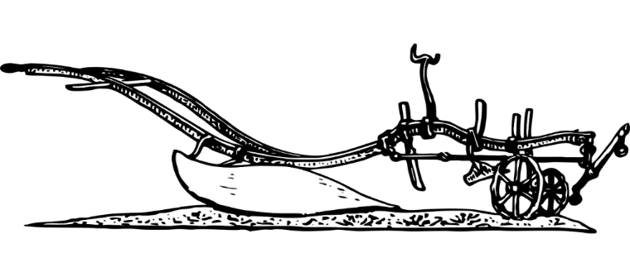

*14*